Does Humidity Cause Death by Heatstroke? Important Evidence from the Cincinnati Sunstroke Epidemic of 1881

Are you worried that the sun will kill you off?

Are you a serious researcher of death by sunstroke?

Are you obsessed with 1881?

No? Well, you’ve come to the right place. Here we’re going to poke fun at the work some researchers did way back in the day, using modern statistics, to see if their claims are actually true.

Motivation

I stumbled across this mildly interesting paper (<https://www.ncbi.nlm.nih.gov/pmc/articles/PMC2272406/>) about the Cincinnati Sunstroke Epidemic of 1881, and two things caught my attention. (Miles 1881) First, there were two pages tabulating all of the data. Second, the author made an interesting claim that I had to follow up on. He claims:

“The object in thus presenting these tables is to prove by the observations, that the *dryer the atmosphere* the greater will be the increase in the death-rate from insolation.”

Well, I’ve seen those tables and they’re pretty dang convincing. 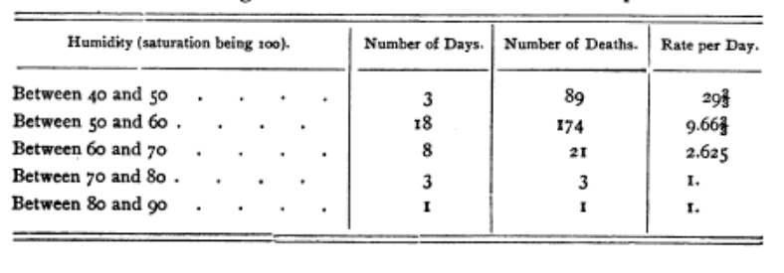

So, convincing tables aside, how do these results hold up to, say Ordinary Least Squares? If he’s right, then we would expect there to be a large negative relationship between the two. I ran a regression, and the results are not so good.

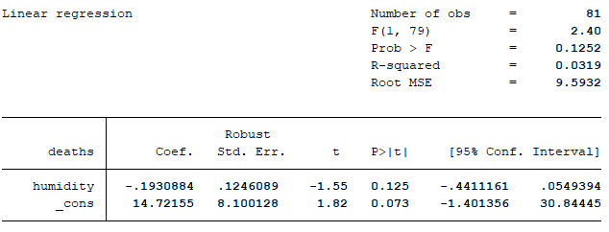

Yes, the coefficient is negative, but the probability that there is no effect and he got this by chance is 12%

“OK” you say, “you’re just cherry-picking results. He clearly said ‘the thermometer being the same, a dry atmosphere is much more conducive to sunstroke than a hot and moist atmosphere’. You need to control for other weather conditions to reproduce his results”